As an expert in corporate strategy, you are asked to advise the CEO of Very Good Inc., a maker of children’s toys. The company is considering acquiring one of three companies. With company A, a maker of plastic components, the goal is to share manufacturing facilities and therefore achieve better capacity utilization for both firms. With company B, another toy manufacturer, Very Good wants to work together to develop new products, as well as create a common procurement department that sources the components they need for their products in larger volumes. With C, which owns a retail distribution network, the plan is for C to distribute Very Good’s products and support them through in store advertising. The CEO wants to know how the synergies differ and what the valuation and management challenges in each of these acquisitions are likely to be.

In Section 1, we stated that the goal of the corporate strategist is to pursue corporate advantage—to create more value from jointly owning a portfolio of businesses than the sum of their values when they are owned independently. When investors have equivalent investment opportunities, the threshold for the extent of corporate advantage that a corporate strategist must create is higher, and can only be met through synergies. In this section, we describe a systematic approach to analyzing synergies.

Despite their centrality to corporate strategy, synergies have remained hard to describe, value and extract, and the word “synergy” itself is in great peril of becoming a mere buzzword. To a large extent, this is because we have lacked sophistication in being able to classify and distinguish different kinds of synergies and their organizational implications in a clear way. This section aims to rectify this.

What are synergies?
In its simplest form, operational synergy potentially exists if two businesses operated jointly are more valuable than the two businesses operated independently. “Jointly operating” implies that decisions across the two businesses are coordinated with the aim of enhancing joint value. The degree of coordination required exceeds simple price taking behavior such as in a market transaction.

In this document, when we say synergy, we will always mean operational synergy. Other forms of synergy that do not require joint operation (e.g., financial synergies or gains from trade) are also feasible. For instance, scale economies in financing may be a driver of alliances or acquisitions. Companies may sometimes be acquired to access a listing on a capital market, to move corporate domicile to a low tax location, buy unused tax deductions, or benefit from tax arbitrage and tax shields. These non-operational financial synergies are not the focus of this document. Our emphasis is on operational synergies, which arise from coordinated decisions about the operations of the two businesses—i.e. decisions about primary and supporting activities across the value chains of the businesses. See box 2.1 for a test for the existence of potential synergies

Box 2.1 The synergy test
The synergy test can be written as:
V(AB) > V(A) + V(B)

V(A) is the net present value of business A when operated independently and V(B) that of B. V(AB) is the net present value of businesses A and B when they operate jointly.

The synergy test differs from the corporate advantage test in two ways. First, corporate advantage is defined in terms of jointly owning businesses and synergies in terms of jointly operating them. The ability to jointly operate and take coordinated decisions across the businesses can sometimes be achieved contractually (e.g., through strategic partnerships), but sometimes requires common ownership (e.g., by merging the two businesses, or by one business acquiring the other). Note that in this section, we focus on understanding the conditions under which synergies potentially exist—i.e., when coordinated decision making across businesses can improve their joint value. The next section (3: Governance costs) analyses when ownership is necessary to realize value from synergies.

Further, as we know from Section 1, with merely payoff rights over two businesses it may still be feasible to create corporate advantage (through risk diversification). However, with decision rights it is also possible to realize synergies between two businesses. In other words, while an investor (e.g. a mutual fund manager) could create corporate advantage, an investor cannot extract synergies. This is why we emphasize joint operations and joint decision making when defining synergies.

Second, the corporate advantage test is about the portfolio of businesses; the synergy test is about any two of such businesses. Thus, for a corporate strategist to create corporate advantage over what an investor can achieve in efficient capital markets, there must at least be some form of synergy (between, at a minimum, two businesses in the portfolio).

Our definition of synergy makes it easy to see why its existence is so important for corporate strategy. It is a basis for meeting the corporate advantage test when investors can diversify unsystematic risks; potential value capture from synergies brings partners to the table to negotiate strategic alliances or acquisitions; it enables acquirers to pay a premium and still make money (since synergies imply private value), and allows CEO’s of publicly listed companies to justify their acquisitions and alliances to their shareholders. Indeed, as we will see, the notion of synergy is also central to understanding organizational structures and relationships between units within a company (Section 10).

Where do synergies come from? Value chains and resources
Operational synergies between businesses entail coordinated decisions about the operations of the businesses. To classify the basic types of these decisions, we find it is useful to begin by representing the operations of each business through its value chain. A value chain represents the set of activities that must be performed to produce a product or a service and bring it to a customer. In an influential account, Porter (1985) distinguished between primary activities (such as inbound logistics, production, out-bound logistics, marketing & sales, service) whose scale of activity varies directly with the level of production, and secondary activities (such as firm infrastructure, human resource management, technology development, procurement) whose scale does not depend directly on the level of production.

Using the example of the maker of children’s toys, Very Good Inc., we can draw a basic value chain as in Figure 2.2.

Figure 2.2 Value chain of a toy maker
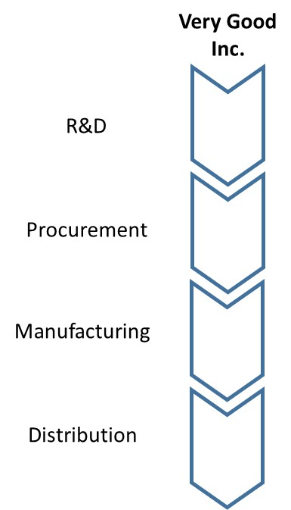

A value chain with 3 to 7 steps provides a good starting point for many analyses. For some purposes, more detail may be required. Note also that in the example above we do not distinguish between primary and secondary activities. This is acceptable in many instances; some instances need a fuller distinction between the two. One important instance of the latter is when considering synergies between corporate headquarters and an individual business. While headquarters by definition does not produce anything, a) it can be the location of centralized functions such as procurement or R&D, and b) it can be the location of skills and brands that can generate value when linked to individual businesses.

Underlying each value chain activity are resources, which enable the performance of the activity. These can be thought of as the factors of production, classically defined as land, labor, and capital. Because of the importance of resources for competitive advantage and also for corporate advantage, a more fine grained definition is useful. Barney (1991) defined resources as all assets, capabilities, organizational processes, firm attributes, information, and knowledge that enables a firm to fulfill the activities in its value chain. Consider Research and Development (R&D) as a supporting activity. The resources underlying this activity include physical infrastructure and equipment (i.e., labs) as well as the capabilities of teams of scientists and engineers (see Figure 2.3). Thus two pharmaceutical firms may both undertake R&D as an important activity in their value chain, but one firm may have an advantage over the other in this activity because of the superior quality of its resources.

Figure 2.3. Value chains and the resources underlying value chain activities
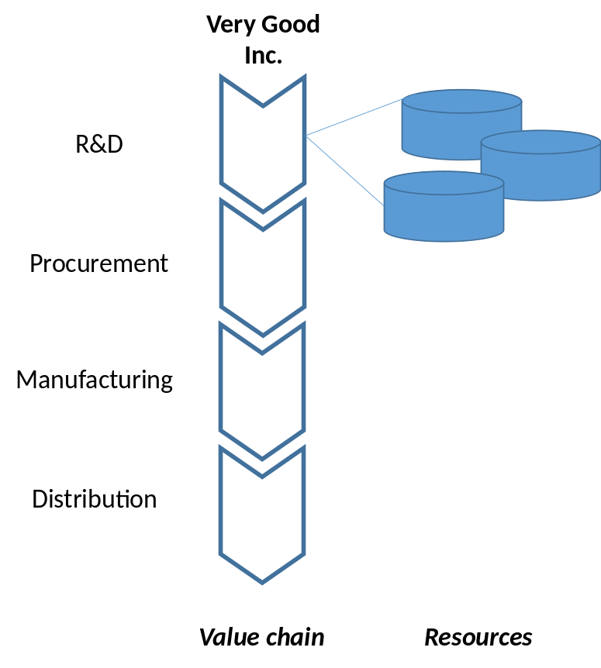

Operational synergies between businesses ultimately must be traceable to links between the value chains of the respective businesses and the resources underlying them. When looking for operational synergies between businesses, we are in effect looking for valuable ways to coordinate decision making across the value chain activities of the two businesses.

But which pairs of activities? What decisions do we coordinate, and how will that create value? To simplify the process of answering such questions, we have developed a structured approach to linking value chain activities across businesses that one might think of as “the algebra of value chains”. Just as in algebra there are four basic operators that one uses on numbers (addition, subtraction, multiplication, and division), there are four basic operators that one uses on value chains in order to extract synergies.

What type of synergies are there?
The four synergy operators are obtained by crossing two dimensions: the similarity of the resources underlying the value chain activities being linked (Low or High), and the extent of modification of the resources underlying these value chain activities that is necessary for value creation (Low or High). These dimensions and the resulting four operators are summarized in Table 2.1.

Table 2.1 The 4 basic synergy operators
High Modification  of resources required | Consolidation | Customization
Low Modification  of resources required | Combination | Connection
 | Involves Similar Resources | Involves Dissimilar Resources

We distinguish between these four different synergy operators that can be applied to the value chains of any two businesses resulting in operational synergies: Consolidation, Combination, Connection, and Customization. Each operator answers the following question: given two value chain activities A and B belonging to two distinct businesses, each operating independently, what are some ways in which operating decisions in these activities could be coordinated to create value? The answers in turn depend on whether we are linking similar or dissimilar resources across the two value chains, and how much modification the resources will require to produce value. Let’s consider these two dimensions in some more detail.

First, the resources being linked may be more or less similar to each other. A classic distinction is between economies of scale and economies of scope. The first indicates that producing more of the same product leads to lower average cost. The second exists when producing different products together leads to lower average cost than if those products had been produced separately. This similar-dissimilar distinction is also useful when thinking about synergies. Linking similar resources produces qualitatively different effects than linking dissimilar resources. Broadly speaking, the former produces the advantages of scale, whereas the latter produces the advantages of scope.

The similarity of resources underlying different value chain activities is a matter of degree. Typically, for two businesses the resources underlying the same value chain activities are more similar than those underlying different value chain activities. For example, a pharmaceutical company’s R&D resources could be more similar to those of a competitor than to its own manufacturing resources. However, even the same generic value chain activity does not imply the same resources. The pharmaceutical company may have strong R&D resources in cell biology and a photo camera producer, strong R&D resources in electronic imaging. Thus, similarity in resources is a matter of degree. For clarity, it is useful to remember that resources underlying different value chain activities are likely to be more unlike each other than resources underlying the same value chain activity.

Second, there can be variation in the extent to which the resources underlying value chains activities being linked must be modified. In certain cases, almost no modification is required. When a bank buys an insurance company in order to sell insurance policies through its retail branch network, neither the activities needed to create insurance policies, nor the activities needed to sell financial products through the branch network change much. In other cases, resources must be modified significantly before value can be created. When a bank buys another bank in order to integrate and reduce the branch network, then the retail activities of (at least) one certainly need to be changed significantly. The extent of modification required is useful to understand the frictions that will eat into the value created by the synergies.

Next we describe the four synergy operators we obtain from crossing these two dimensions, in more detail.

1. Consolidation (involving similar resources and high modification)
This is the most intuitive synergy operator. It involves creating value by rationalization across highly similar resources (from similar value chain activities) by eliminating redundancies. This synergy operator affects mostly costs and invested capital. Figure 2.4 shows how the value chains across two companies might look after the consolidation operator has been applied to the first value chain activity in their respective value chains (e.g. procurement activity). Because the gains here come from elimination, the resources at one or both sides need to be trimmed and possibly adjusted. Hence, the modification to the resource base is substantial.

Figure 2.4 Consolidation (similar resources and high modification)
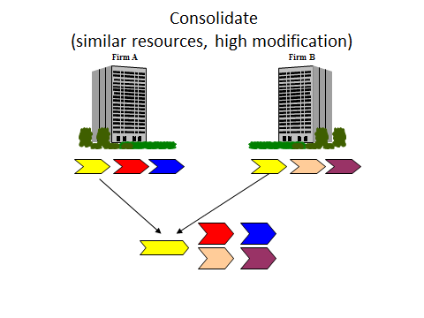

Examples of Consolidation
- Reduction in headcount by merging departments, where the same work is done by fewer people.
- The formation of tangible resources such as shared services centers (e.g. finance, HR, treasury, legal, accounting) or intangible resources (e.g. brands, expertise) at the corporate level, which may require fewer people and lesser investment than if these were duplicated at the business unit level.
- Reduction in capital invested by closing factories. For example, 4 similar factories operate at 60% of full capacity. One is closed and the remaining operate at 80%.

2. Combination (involving similar resources and low modification)
This synergy operator entails creating value by pooling highly similar resources (from similar value chain activities). Two instances are combining purchasing to obtain volume discounts or acquiring a competitor and then raising prices for customers. These effects can impact either costs (e.g. bargaining power with suppliers) or revenues (e.g. bargaining power with customers). Regulators are typically wary of these gains derived from market power because they are associated with corresponding losses for either suppliers or customers. Acquisitions might be blocked based on anti-trust grounds if the market power increases significantly. The extent of necessary modification of the resources in this case is however modest. Figure 2.5 shows how the integrated value chains across two companies might look after the combination operator has been applied for the first activities in their respective value chains.

Figure 2.5 Combination (similar resources and low modification)
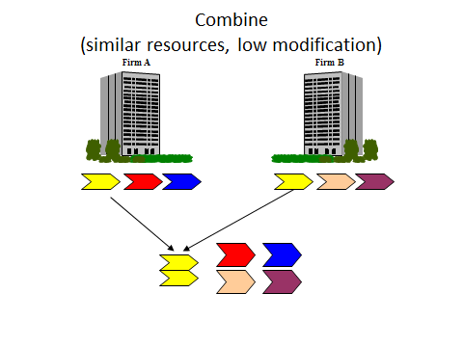

What is common to consolidation and combination is that on application of these operators, the initial value chain activities to which they have been applied disappear, as they are merged. The difference lies in whether the merged value chain activity is smaller than (consolidation) or the same (combination) as the combined size of the formerly independent activities; and whether modification of resources is necessary (consolidation) or not (combination).

Examples of Combination
- Volume discounts from increased procurement volume and the resulting increase in bargaining power with suppliers.
- Increased political influence from a larger size. For example, a bigger corporation is able to extract better terms for doing business from the government than a smaller corporation.
- The formation of a market-leader might make other players compete less intensively out of fear of retaliation. This would result in higher prices.
- Corporate HQ might have greater bargaining power with providers of expertise (e.g. talent, consultants) and finance than individual businesses.

3. Customization (involving dissimilar resources and high modification)
This synergy operator involves creating value by co-specializing dissimilar resources (from similar or dissimilar value chain activities) in order to create greater joint value. For instance, a software company and a mobile phone company partner to develop handset hardware and operating software that work very well together because the technologies could be customized to each other; company A allies with B to provide an input or complementary technology/service that is customized to its requirements. The key idea is the customization of resources results in improved value in production or consumption (either the final product works better or costs less—producing either revenue or cost synergies). This customization implies investments idiosyncratic to the pairing of value chain activities. By definition, this customization involves modification of resources (on one or both sides).

For instance, the transfer of best practice—one company’s knowledge coupled with another’s assets—can create unique value. The second company will have to customize their assets to the first’s way of working. Figure 2.6 shows how the value chains across two companies might look when linked through the customization operator—the second activity of both value chains are the ones affected.

Figure 2.6 Customization (dissimilar resources and high modification)
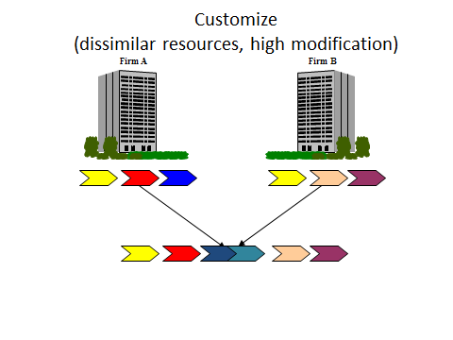
Examples of Customization
- Creating a customized bundle of product or services (“solutions”) to meet the needs of particular clients (and significant modification of resources is required).
- Transferring intangible assets such as best practice, knowledge, or IP from one business to another to improve operations.
- Building a dedicated warehouse with spare parts next to a manufacturing site to minimize delivery times.
- Management and functional expertise centralized at HQ, and applied to improve the operations of different businesses

4. Connection (Involving Dissimilar Resources and Low Modification)
This synergy operator generates value by simply pooling the outputs of dissimilar value chain activities, with little modification. For instance, customers may value being able to buy a bundle of different products or services together—in order to economize on the transaction costs of making separate purchases, for instance—then the sales and marketing teams for two different product teams may be connected so that they may jointly sell a product bundle, or cross-sell each other’s products. In effect the product development of one business is being connected to the distribution channel of another.

Figure 2.7 Connection (dissimilar resources and low modification)
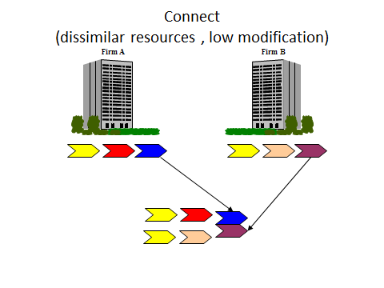

Examples of Connection
- Provide a one-stop shop to reduce search and transaction costs for customers. The actual resource may require little change.
- Cross selling of products to each others’ customers. For example, a bank selling insurance products to its customers.
- Applying a common brand, (of which HQ might be the custodian) across different businesses, raising their revenues

Analyzing synergies using the 4C’s framework offers several benefits. First, it provides a structured approach to identifying synergy opportunities by analyzing the value chain. Given two businesses, the analyst can systematically explore the feasibility of each type of synergy. Starting with the resources underlying value chain activity 1 in business 1, for instance, one can first look for similar resources in the value chain of business 2, to find opportunities for Consolidation and Combination. Then one can look at dissimilar resources in business 2 to look for opportunities for Connection and Customization. Next, we can do the same for resources underlying value chain activity 2 in business 1. By the end of this process, you can be sure that you have not missed out any opportunities for extracting synergy.

Second, it is helpful in differentiating synergies along aspects such as the difficulty of predicting their value, ease of realization, and steady state management efforts required. This advantage arises from the fact that the different synergy operators may have distinctive “footprints” along a number of such dimensions (Table 2.2).

For instance, consider a merger in which the synergies in the procurement function arise from consolidation (headcount reduction) as well as combination (procurement volume). In the same merger, let us assume that there are some synergies from connection (cross–selling) as well as customization (product bundling). In what meaningful ways will these synergies differ from the perspective of valuation and post-merger integration?

In this case, we should expect the direct cost of extracting consolidation and customization synergies will be higher than the combination and connection synergies respectively because of the greater need for resource modification in the former. At the same time, the consolidation synergies are perhaps the easiest to forecast because clarity about the extent of redundancy is usually easier to obtain; forecasting the effects of enhanced bargaining power may be relatively harder. Similarly it may be easier to estimate the impact of skill transfer on productivity than of product bundling on consumer’s willingness to pay. Finally, given the nature of consolidation and customization synergies, once the initial process of removing redundancies or ensuring inter-operability is completed, there is little further need for ongoing management effort, whereas connection and combination may require a low but constant level of coordination of activity. These differences in the cost of implementation, managerial effort needed, and predictability should affect how synergies are valued, and how post-merger integration is planned.

Finally, and perhaps most important, the 4C’s approach makes it easy to explain the sources of value to investors, managers, and customers.

That said, it is important to realize that synergy analysis begins, not ends with the 4C’s. It is complete only when a financial forecast of synergy realization is made. Quantification of synergy impact is critical for at least three reasons. First, it forces you to make your assumptions explicit. Second, it guides you towards synergies that are really value enhancing, i.e., which have significant revenue, cost, or invested capital implications. We have found that our students were often very creative (and sometimes even entertaining) when coming up with synergies. While this is good and desirable early on in an analysis, eventually only those synergies with actual net benefits should be pursued. Third, it provides a ranking of which synergies to prioritize. In the appendix to this section we provide an illustration how a qualitative 4C’s assessment can be quantified, using value drivers (i.e., financial measures that are affected by synergies).

Who benefits from synergy? One-sided vs. two sided effects
One important distinction to bear in mind when analyzing synergies is whether they are one-sided or two-sided. To see the difference, consider two firms, A and B whose stand-alone value is V(A) and V(B) respectively, and their value when jointly operated is V(AB). Assuming the synergy test introduced in this section is met, let the synergies from linking their value chains be S (where S = V(AB)-V(A)-V(B)). Let’s breakdown these synergies into S(A) and S(B) such that S=S(A)+S(B). Here, S(A) and S(B) represent the synergies experienced by A and B respectively.

Passing the synergy test implies that S(A)+S(B)>0. The synergies are two-sided if both businesses benefit, i.e., S(A)>0 and S(B)>0. They are one-sided if one business gains more than the other business loses, e.g. S(A)>0 and S(B)<0 (and S(A)+S(B)>0). To make the pursuit of synergies worthwhile for both businesses in this case, they must reach an agreement on some form of side payment from one business to the other. Forms of these side payments include an acquisition premium, in which an acquirer may pass on some of the one sided benefits it experiences to the target, or upfront payments in alliances by one partner to another.

An important implication of this distinction between one and two sided synergy effects is that it is necessary to estimate the impact of synergies on the value of each business involved separately.
 | Consolidation | Combination | Customization | Connection
Involves linking | Similar resources | Similar resources | Dissimilar resources | Dissimilar resources
Degree of resource modification | High | Low | High | Low
Need for active collaboration between personnel from the different value chains involved | High initially, low eventually | Moderate, constant over time | Moderate, constant over time | Low, constant over time
Impact: One sided or Two sided | One sided | Two sided | One sided or Two sided | Two sided
Key value driver | Modifying the value chain activities by disposal/better utilization of underutilized resources or excess capacity | Increasing bargaining power by pooling the unmodified activities of the value chain activities | Modifying the value chain activities through specializing them to each other to increase their combined value | Pooling the outputs of unmodified value chain activities to increase their value
Value drivers affected | Cost/ Assets | Cost/Revenues | Costs/Revenues/Assets | Revenues
Examples | Eliminate redundancy (or share excess capacity) in functions/operations/  technology development projects/sales forces/plants/equipment (i.e. tangible assets) | Gain bargaining power relative to suppliers; market power; government | R&D customized to manufacturing; Software customized to hardware; Application of one partner’s business model/knowledge on another’s assets; “Solution” selling; joint product development | Cross selling; Product bundling; Linking product development of one company to distribution channels of another; sharing brands
Table 2.2 Synergy operators and their attributes

Do negative synergies exist?
There are circumstances in which the value of two businesses under coordinated decision making may actually be lower than the sum of their values when they operate independently. One common instance is brand dilution. Imagine a watch company with a brand known for luxury operating a budget jewelry store under the same brand; or a film studio with a brand known for its family values operating a film business with violent action movies as a subsidiary under the same brand.

A second instance of negative synergies arises from organizational complexity. Since actions have to be coordinated across businesses to extract operational synergies, this necessarily implies some loss of initiative, independence and speed in decision making. These can be ignored when the gains from coordinated decision making across businesses are large; but when they are not, these costs still remain and can create a net negative synergy from joint operation. One of our students once described these as “Dilbert” costs, after Scott Adam’s iconic cartoons about the costs of bureaucracy, and the name has stuck in our minds since.

Another situation of negative synergies can arise because of concerns about independence of action of two businesses under the same corporate umbrella. If business A is an internal supplier to business B, it may be difficult for A to find clients outside the corporation, who are likely to be rivals of B, and will suspect collusion between A and B. Similarly, if A and B each have clients who are rivals, these clients will suspect possible leakage of valuable information through their respective vendors into the hands of their rivals. This is a significant concern in the advertising industry, where when two firms who serve rivals (say Coke and Pepsi) merge, the chances of both keeping their clients is low.

More generally, in this section we have focused on the potential benefits from collaboration arising from joint decision making. However, achieving collaboration is typically not easy but requires creating conditions that allow people to work effectively together. In the next section, we discuss impediments to collaboration, which generate governance costs.

An application: How to look for synergies in Very Good Inc.
Now we have all the elements in place to advise the CEO of Very Good Inc. Recall that Very Good Inc. is considering acquiring one of three companies: company A (a maker of plastic components) for sharing manufacturing facilities, company B (another toy manufacturer) for joint R&D and procurement and company C (a retailer) for enhanced distribution.

Begin by drawing the value chain of each business (see Figure 2.8).

Figure 2.8 Value chain overview
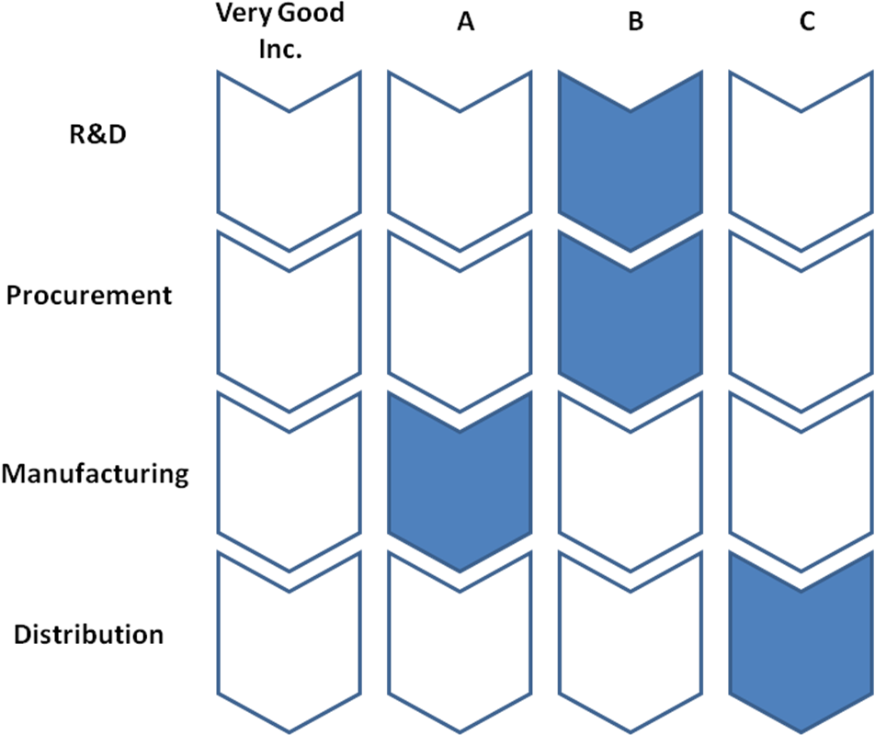

The three acquisitions are different because the sources of potential synergy are distinct. A involves Consolidation, B involves both Customization and Combination, while C involves Connection synergies. These differences mean that the uncertainty about outcomes, the cost of implementation, and the linkages across value chains is likely to be different across the cases. These differences should be reflected in the valuation and management of these acquisitions.

Consolidation based synergies are easiest to predict and value, and may require a large up-front investment of managerial time and effort, but lower levels of steady state management efforts between partners. Customization synergies are harder to predict, and also require significant levels of ongoing collaboration between partners. Connection and combination synergies require lesser resource modification, so will be relatively easier to extract than consolidation and customization. Thus, C will be the cheapest acquisition to implement but perhaps the hardest to value precisely; A will be the opposite, as it may be the easiest to value precisely, but expensive to implement. B will lie between both in terms of ease of valuation and cost of implementation.

<APPLICATION ENDS>

Frequently Asked Questions
1. I am familiar with a synergy classification based on costs and revenues. Why do you suggest the 4Cs?
A fairly common and intuitive way of thinking about synergies classifies them into cost and revenue synergies. Cost synergies exist between two businesses if their joint variable or fixed costs of production can somehow be lowered by linking the two businesses. Revenue synergies exist if their joint outputs can somehow be made more valuable by linking the businesses. For instance, cost synergies could arise from cutting redundant jobs; revenue synergies from cross selling.

While this is a helpful first cut at classifying synergies, it is in fact quite crude. It offers little insights about the logic of value creation (for instance cost synergies can arise either from Consolidation or Combination), valuation or organizational implications. Apart from suggesting the vague intuition that cost synergies are somehow more “reliable” than revenue synergies, this distinction tells us very little about why this should be the case, the organizational implications of the two kinds of synergies, or the managerial efforts that will be required to extract the relevant synergies.

2. Do the nature of synergies differ in so called “horizontal”, “vertical”, and conglomerate acquisitions?
Horizontal acquisitions are in the same business, vertical acquisitions are in subsequent businesses, and conglomerate acquisitions are in businesses that are neither in horizontally nor vertically related businesses. Since one dimension of the 4Cs is similarity of resources (which depends on similarity in the value chain activities), the type of synergies will be different across the type of acquisition. Conglomerate acquisitions may have few synergies between businesses (but may have some between HQ and business), vertical acquisitions are less likely to rely on consolidation and combination synergies; horizontal acquisitions may have all four types of synergies.

3. Is buying out the competition a form of synergy?
Yes. By coordinating decision making, two businesses operating as one may choose to raise prices and hence improve their value compared to the case when they operate independently as competitors. This is effectively a combination synergy; the combined firm increases its bargaining power with its customers (and possibly its suppliers). Regulators typically do not like this, but when legally permitted because the increase in market power is below thresholds, such a form of synergy can be a justification for doing an acquisition.

4. Help! I keep mixing up the different Cs. Is that a problem?
No. We occasionally do too. The goal is not to classify a given synergy into one of the four Cs. Instead the 4Cs provide a search tool to look for synergy opportunities in a reliable and comprehensive manner. What we call a given synergy is of less importance.

5. Is relatedness a good measure of synergy potential?
Measures of relatedness are frequently used in studies that investigate how diversification influences a corporation’s performance (see Palich, Cardinal, and Miller, (2000) for an overview of the empirical literature). In these studies, an industry classification system (e.g. the SIC codes in the United States) is typically used to measure the extent and nature (related vs. unrelated) of diversification. Industry classifications are based on similarity of products and customers. These measures are not very useful indicators of operational synergy potential. Synergy potential derives from the value chain, not from the outputs of the value chain (i.e. products) or targets of the value chain (i.e. customers). In other words, if a business is defined in terms of who (customers), what (products), and how (value chain), then the synergies stem from the value chain.

That said there are certain forms of synergy between businesses that are driven by similarity. When businesses are similar in terms of the sizes of capital investment projects, time spans of investment projects, sources of risk, stages in their industry life cycles, performance goals and measures etc., then they create what is known as a “dominant general management logic” which binds the businesses together and makes it easier to administer them jointly. One could view these as creating a form of synergy arising from consolidating management expertise needed to administer each business.

6. How do the mathematical definitions of corporate advantage and synergy differ?
Corporate advantage concerns businesses that are jointly owned and synergy involves businesses that are jointly operated. To distinguish between them, we have used “[]” for the corporate advantage test and “()” for the synergies test.
We represent the four quadrants as follows:
I : V(A) + V(B): NPV of businesses owned and operated separately
II: V(AB): NPV of businesses operated jointly
III:V[AB]: NPV of businesses owned jointly
IV:V[(AB)]: NPV of businesses owned and operated jointly
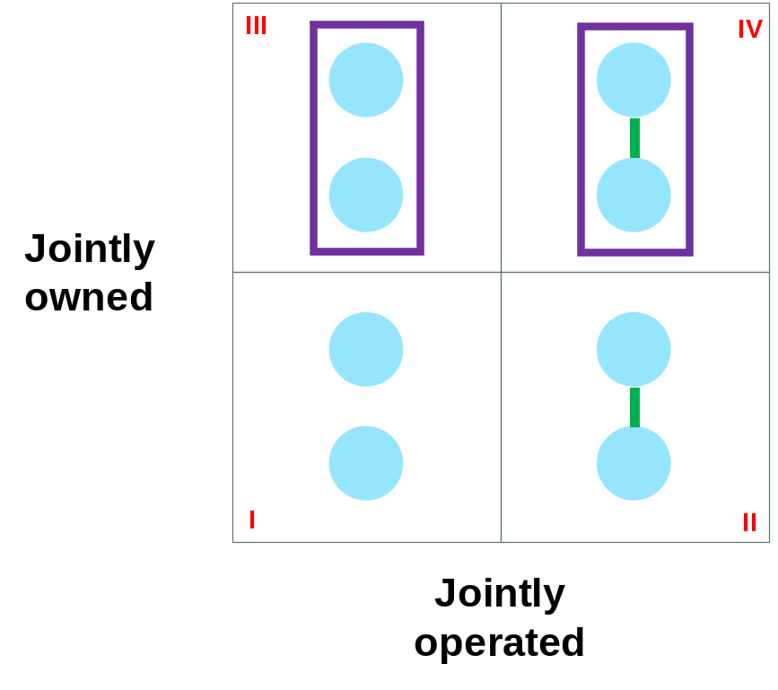

Thus the corporate advantage test compares quadrants III vs. I and IV vs. II; the synergy test compares quadrants IV vs. III and II vs. I.

7. Is an internal capital market a form of synergy?
An “internal capital market” refers to the fact that businesses get funding from corporate headquarters rather than directly from external sources (e.g. banks, bondholders, shareholders). While the empirical evidence on the average performance of internal capital markets is mixed, they appear especially helpful when external capital markets are underdeveloped (e.g. in some developing economies) or inaccessible (e.g. in a financial crisis). Because this is a form of financial (i.e. non-operational) synergy, this is not the focus of the document. However, we will discuss the organizational implications of central resource allocation in section 11 on corporate headquarters.

Academic Background
Our synergies framework (the 4C’s) builds on earlier work by Haspeslagh and Jemison (1991) and Dussauge and Garrette (1998) who discussed synergies in acquisitions and alliances respectively.

To learn more about value chains, see:
Porter, M. E. (1985). Competitive advantage: Creating and sustaining superior performance. New York, USA: Free Press

For a thorough treatment of resources and their importance for strategy, see:
Barney, J. B., & Clark, D. N. (2007). Resource-based theory: Creating and sustaining competitive advantage. Oxford, UK: Oxford University Press.
Levinthal, D.A., & Wu, B. (2010). Opportunity costs and non-scale free capabilities: Profit maximization, corporate scope, and profit margins. Strategic Management Journal, 31(7): 780-801.

On the importance of synergies, see:
Milgrom P., & Roberts, J. (1990). The economics of modern manufacturing: Technology, strategy, and organization. American Economic Review, 80(3), 511-528.

Milgrom P., & Roberts, J. (1995). Complementarities and fit: Strategy, structure, and organizational change in manufacturing. Journal of Accounting and Economics, 19(2-3), 179-208.

For an application of synergies in the context of M&As, see:
Barney, J. (1988). Returns to bidding firms in mergers and acquisitions: Reconsidering the relatedness hypothesis. Strategic Management Journal, 9, 71-78.
Capron, L., & Pistre, N. (2002). When Do Acquirers Earn Abnormal Returns? Strategic Management Journal, 23(9), 781–794.

Ahern, K. R., & Weston, J. F. (2007). M&As: The good, the bad, and the ugly. Journal of Applied Finance, 17(1), 5-20.

Palich, L.E., Cardinal, L.B., & Miller, C. C. (2000). Curvilinearity in the diversification-performance linkage: An examination of over three decades of research. Strategic Management Journal, 21, 155-174.
Prahalad, C. K., & Bettis, R. A. (1986). The dominant logic: A new linkage between diversity and performance. Strategic Management Journal, 7(6), 485-501.

